

EC-200 Data Structures
LAB MANUAL # 09

Course Instructor: Dr. Anum Abdul Salam

Lab Engineer: Engineer Hira Irshad

Student Name: _______________________________________________

Degree/ Syndicate: ____________________________________________

 | Trait | Obtained Marks | Maximum Marks
R1 | Application Functionality 20% |  | 20
R2 | Specification & Data structure implementation  30% |  | 30
R3 | Reusability  10% |  | 10
R4 | Input Validation  10% |  | 10
R5 | Efficiency  20% |  | 20
R6 | Delivery  10% |  | 10
R7 | Plagiarism above 60% |  | 0
 | Total |  | 100

Total Marks = O𝒃𝒕𝒂𝒊𝒏𝒆𝒅 𝑴𝒂𝒓𝒌𝒔 (∑⁶_{𝟏} 𝑹_{𝒊} ∗ 𝑹₇)

Lab # 09: Implementation and Applications of Trie

Lab Objective:
To implement and use trie ADT.
Lab Description:
A trie is a type of a multi-way search tree, which is fundamentally used to retrieve specific keys from a string or a set of strings. It stores the data in an ordered efficient way since it uses pointers to every letter within the alphabet.
The trie data structure works based on the common prefixes of strings. The root node can have any number of nodes considering the amount of strings present in the set. The root of a trie does not contain any value except the pointers to its child nodes.
The real-world applications of trie include − autocorrect, text prediction, sentiment analysis and data sciences.
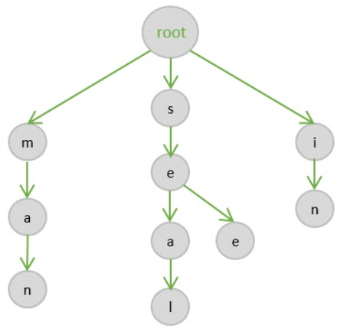
Figure 9.1: Trie Data Structure
Basic Operations in Tries:
The trie data structures also perform the same operations that tree data structures perform. They are
- Insertion
- Deletion
- Search
Insertion operation:
The insertion operation in a trie is a simple approach. The root in a trie does not hold any value and the insertion starts from the immediate child nodes of the root, which act like a key to their child nodes. However, we observe that each node in a trie represents a singlecharacter in the input string. Hence the characters are added into the tries one by one while the links in the trie act as pointers to the next level nodes.
Deletion operation
The deletion operation in a trie is performed using the bottom-up approach. The element is searched for in a trie and deleted, if found. However, there are some special scenarios that need to be kept in mind while performing the deletion operation.
- Case 1 − The key is unique − in this case, the entire key path is deleted from the node. (Unique key suggests that there is no other path that branches out from one path).
- Case 2 − The key is not unique − the leaf nodes are updated. For example, if the key to be deleted is see but it is a prefix of another key seethe; we delete the see and change the Boolean values of t, h and e as false.
- Case 3 − The key to be deleted already has a prefix − the values until the prefix are deleted and the prefix remains in the tree. For example, if the key to be deleted is heart but there is another key present he; so we delete a, r, and t until only he remains.
Search operation
Searching in a trie is a rather straightforward approach. We can only move down the levels of trie based on the key node (the nodes where insertion operation starts at). Searching is done until the end of the path is reached. If the element is found, search is successful; otherwise, search is prompted unsuccessful.

Lab Task:
Modern applications such as search engines, messaging apps, and IDEs provide real-time suggestions as users type. These suggestions improve user experience by predicting possible completions of a word or query.
In this lab, you will design and implement a Search Suggestion System using the Trie data structure. The system will take a large dictionary of words from a file and dynamically suggest words based on user input.
Your system must:
- Load a text file words.txt containing words.
- Insert all words from the file into a Trie.
- Accept user input character by character.
- Display top suggestions for the current prefix.
- Handle:
  - No matches
  - Case-insensitive search
  - Dynamic updates as user types
Run the program and test for these prefixes character-by-character: app, ban, cat, z

